Lyla Shami

CS 211

Instructor:

**Bear Class**

When the program starts, I expect to see all the bears to be slash characters. Half of the slash characters are white, and the other half is black.

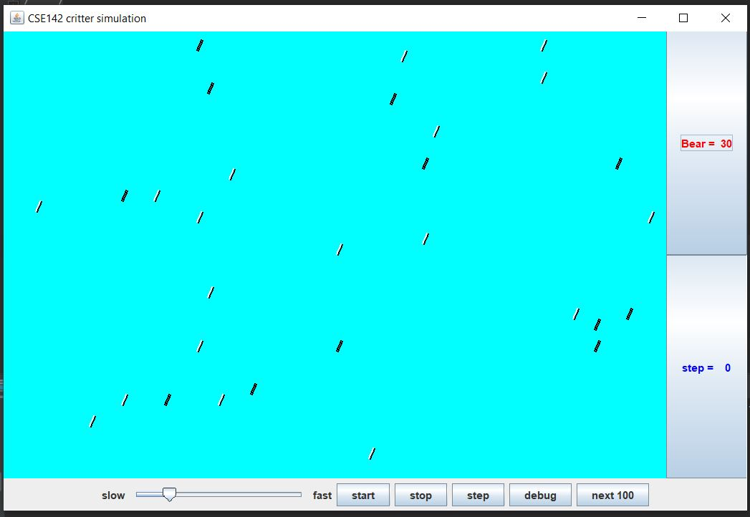

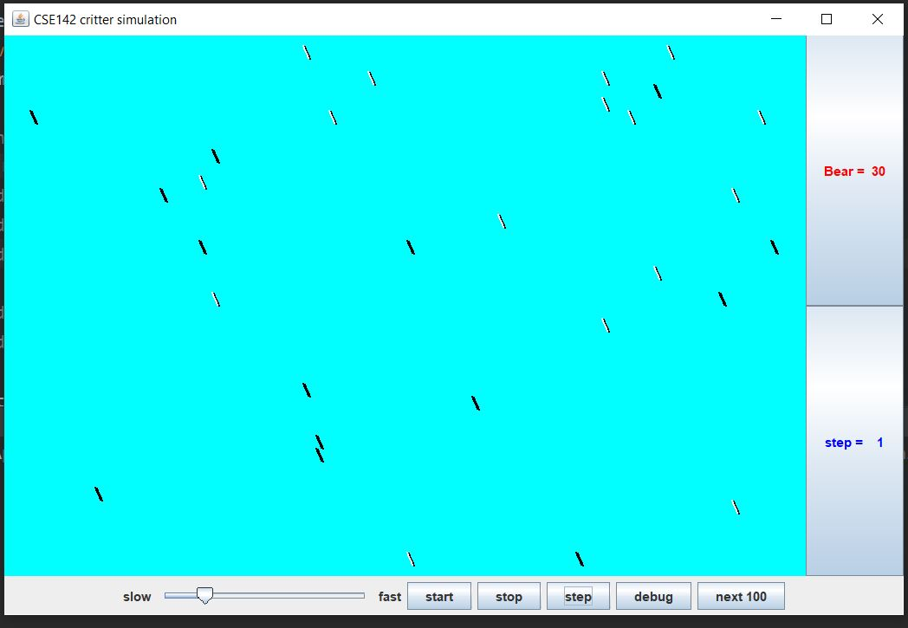

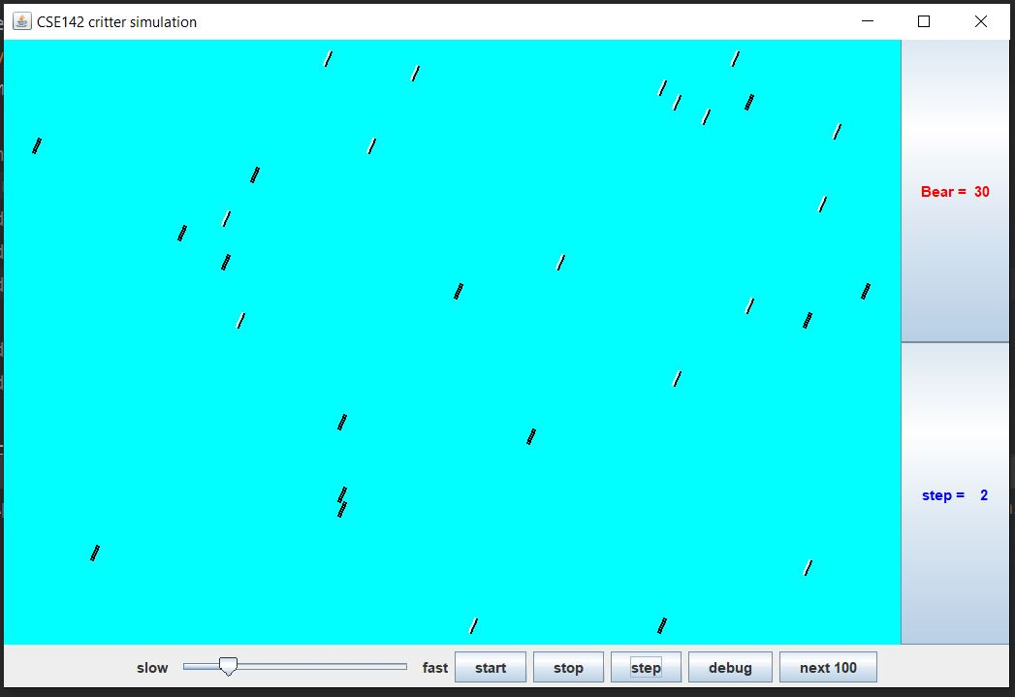

The slashes are supposed to switch to backslashes and back to slashes with each step. So, I expected each of the slashes to switch with each step.

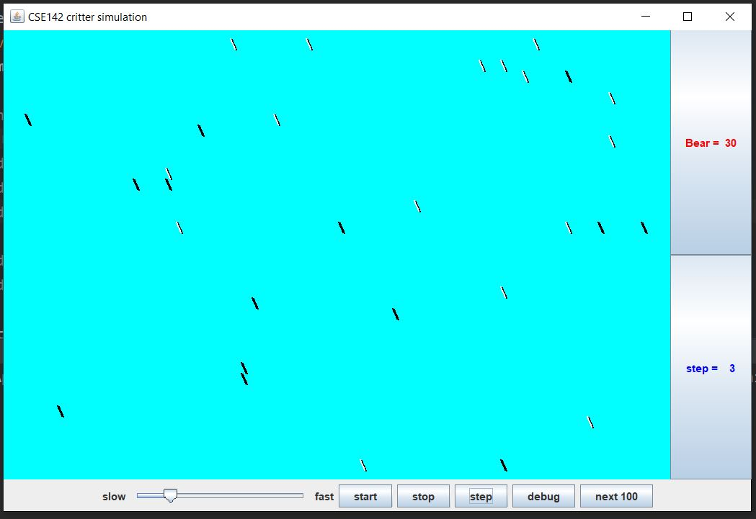

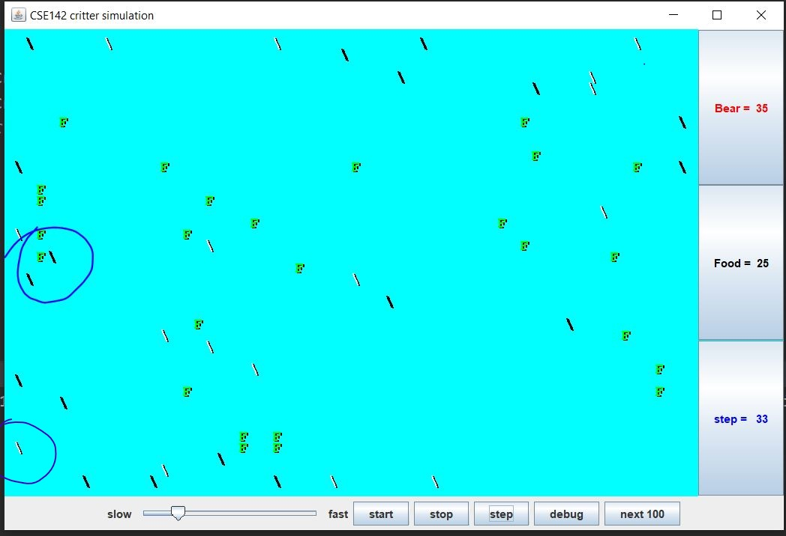

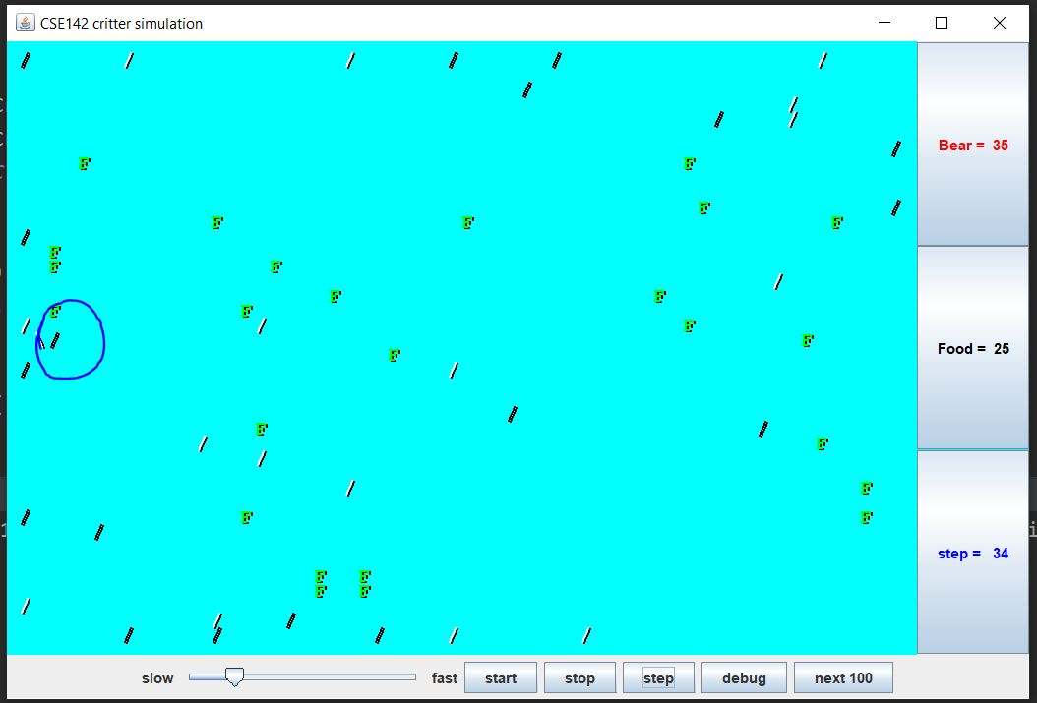

I expect the movement for the bears is to be as follows: the bears infect whatever's in front of them other than bears themselves. If there is nothing Infront of the bears, then they should hop and if the bears bump into each other they should turn left.

**Lion Class**

The lion class is expected to randomly pick between 3 different colors: green, blue and red. Every three moves that the lion makes should also change the lion’s color. These two different slides show the color change between every 3 moves the lion is making. The lion should infect if there is anything infont of them.

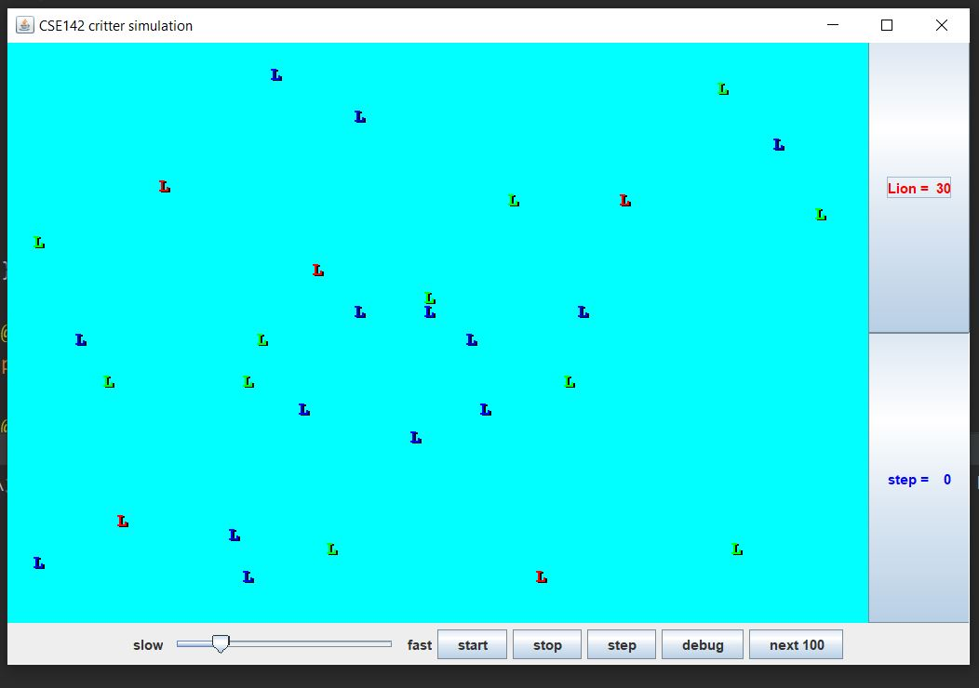

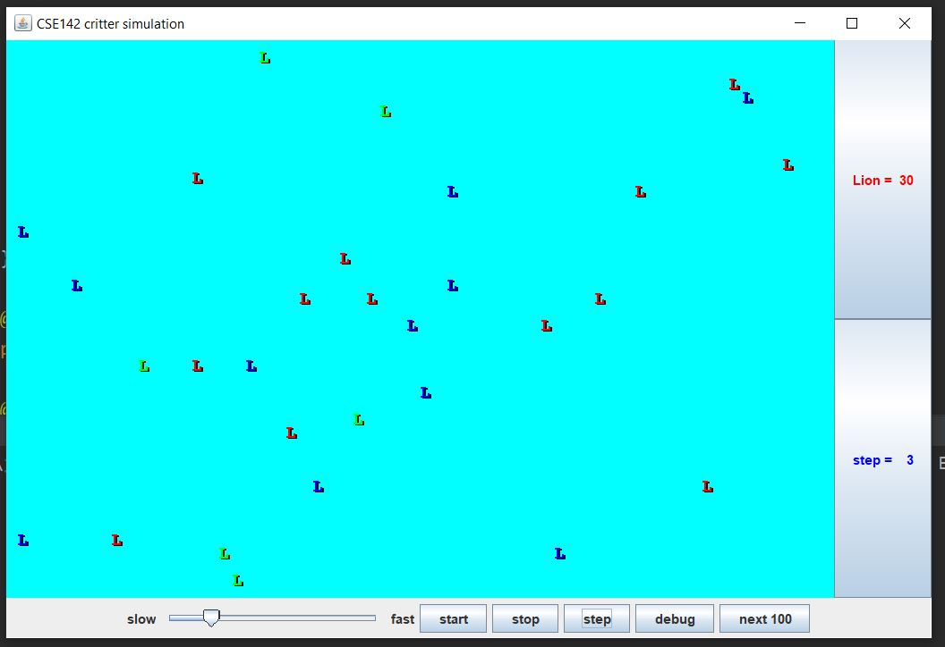

the lion should turn left if there is a wall right Infront of the lion or the right of the lion. The lion should turn right if there is another lion Infront of them.

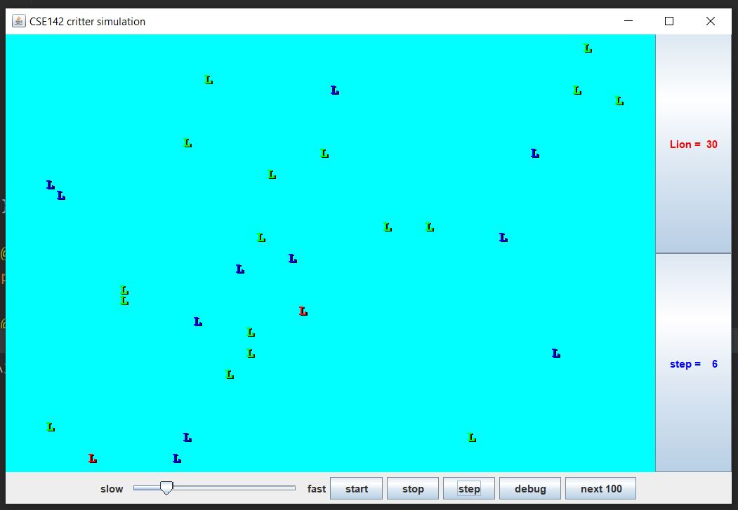

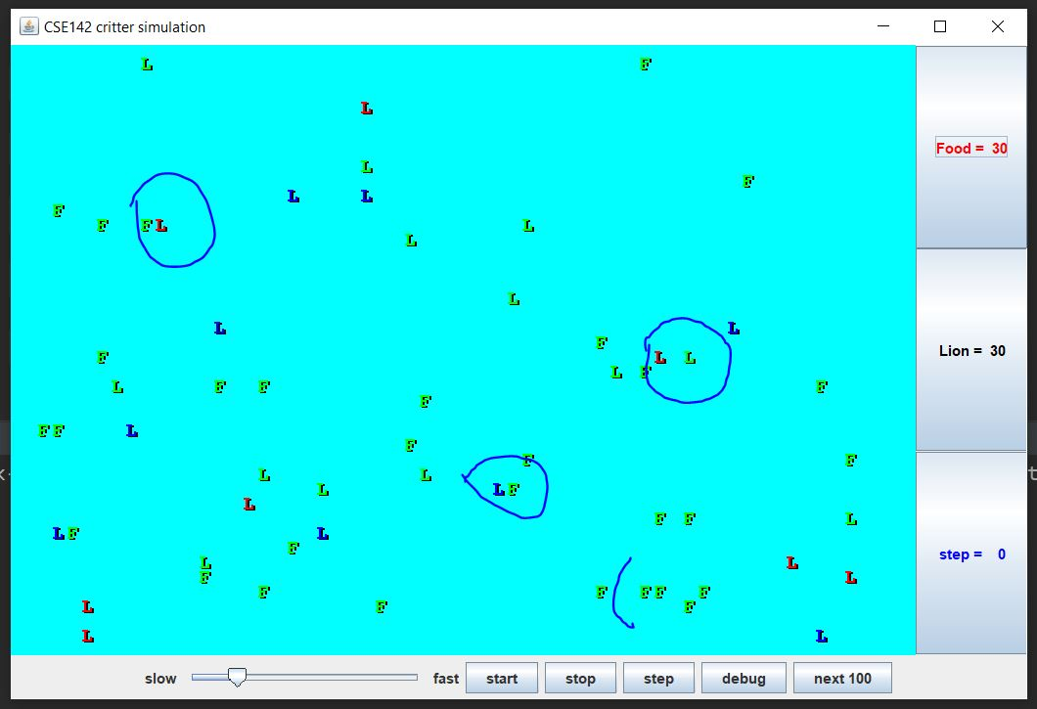

The lion should infect if there is anything infont of them. the lion should turn left if there is a wall right Infront of the lion or the right of the lion. The lion should turn right if there is another lion Infront of them.

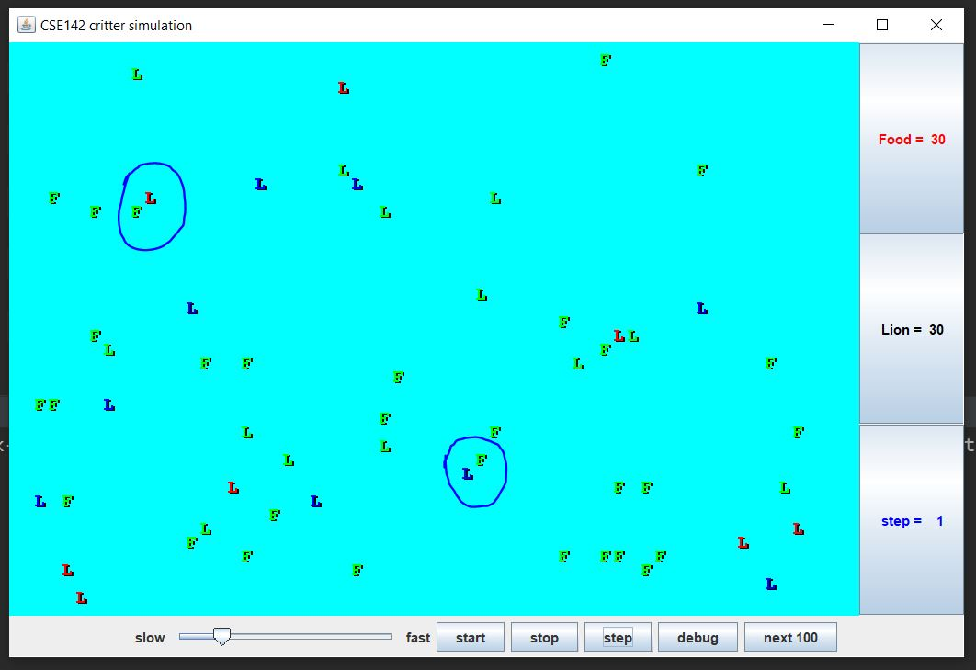

**Giant Class**

Giants are supposed to alternate between 6 sounds: fee, fie, foe, fum. The giants will first start out with fee for six moves, then move on to file for the next six moves, then move on to foe for the next 6 moves and so on.

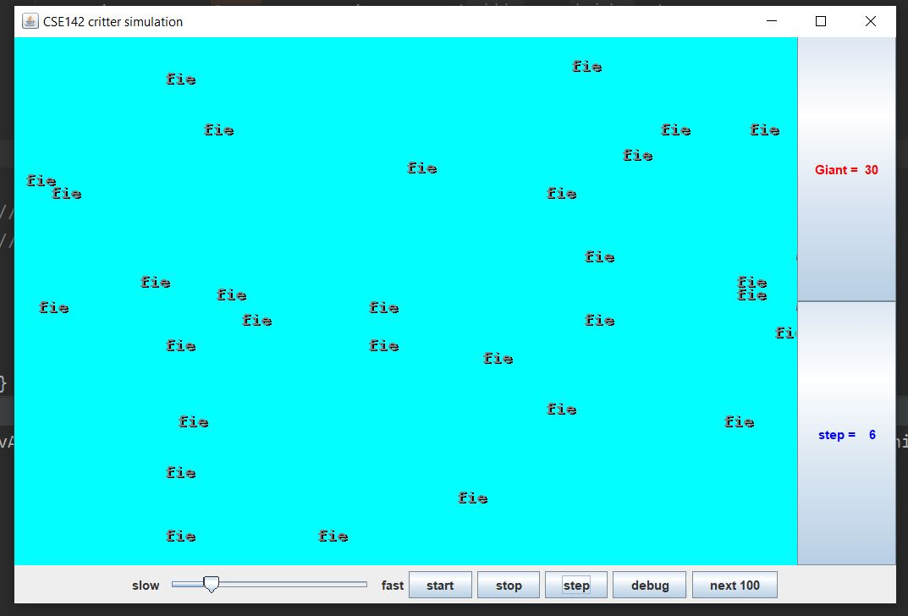

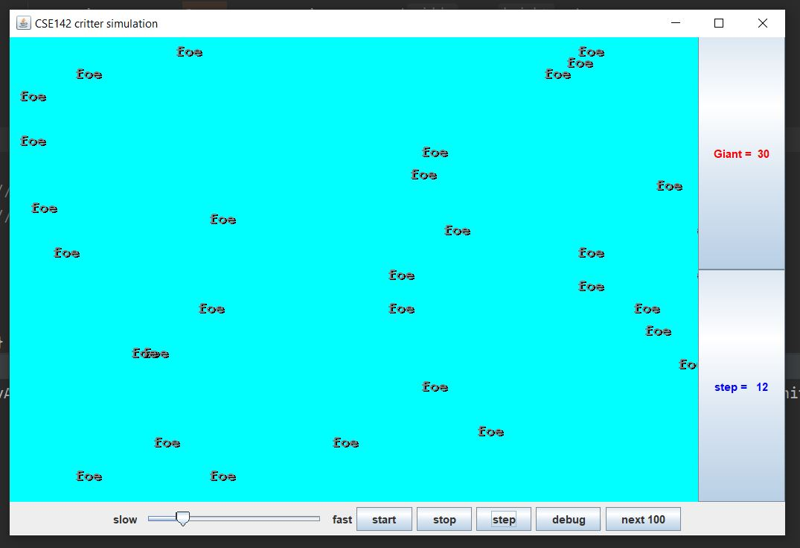

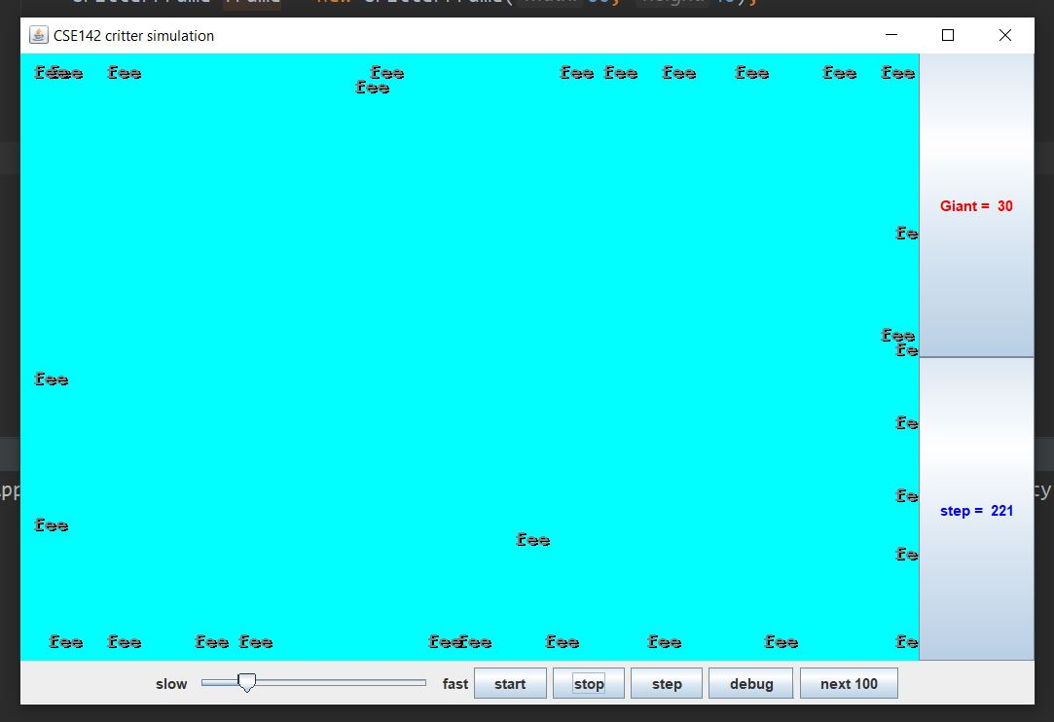

So, the sound name of the giant changes every 6 moves. The giants are also expected to move in a clockwise motion, clinging to the walls. The giants move are supposed to infect whatever is Infront of them, otherwise they are just supposed to hop or turn right.

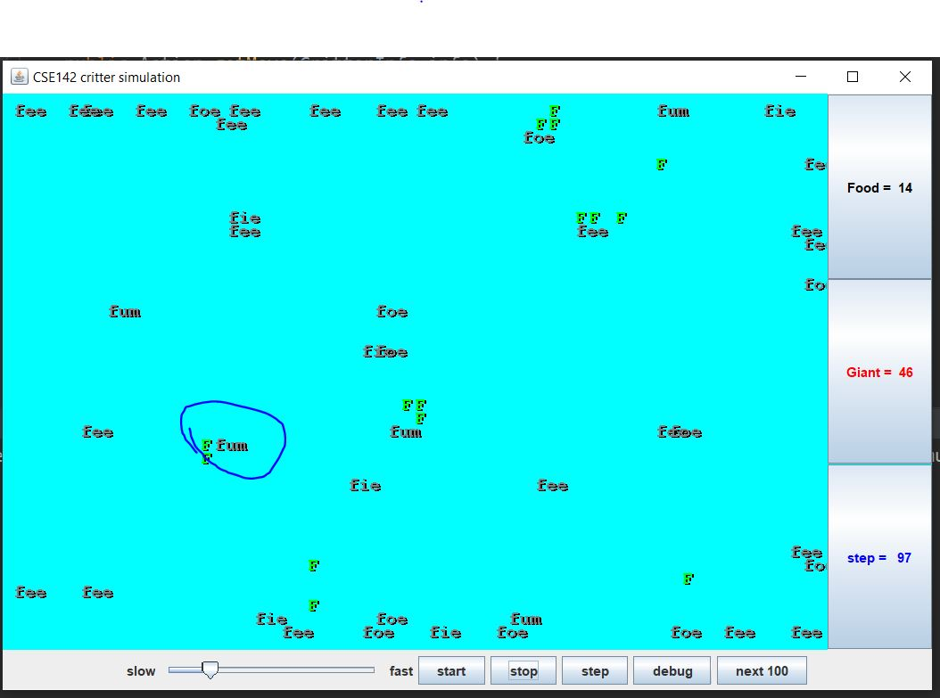

**lShami Flamingo Class**

I created a flamingo class. The flamingos are supposed to cling to the walls, I wanted them to stay compact and together, instead of moving around.

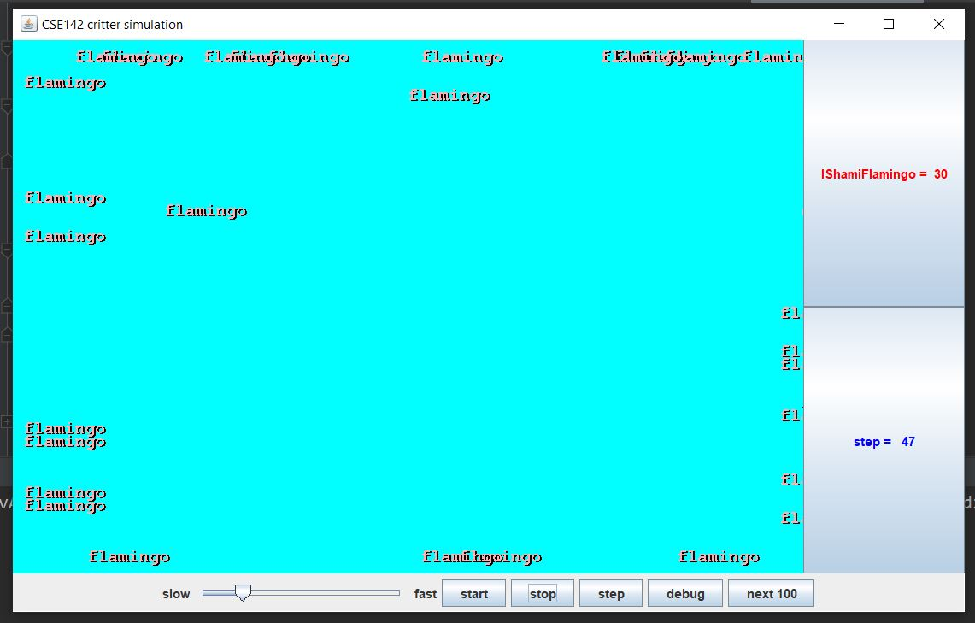

When it comes to movement, the flamingos are supposed infect if there is anything Infront of them. If there back is clear and their front is clear they are supposed to hop and or turn right.

